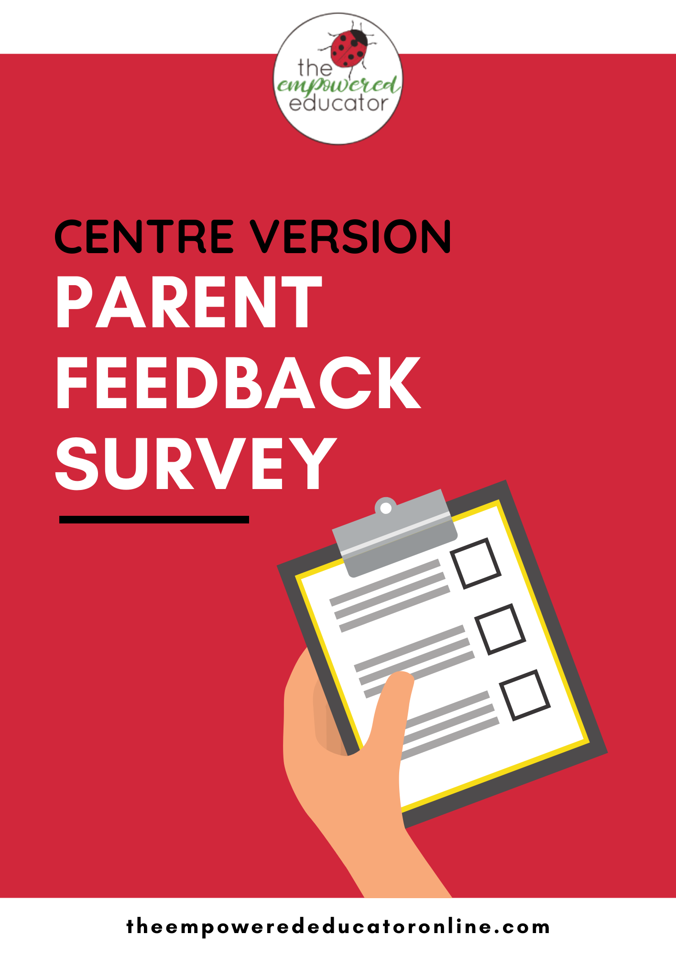
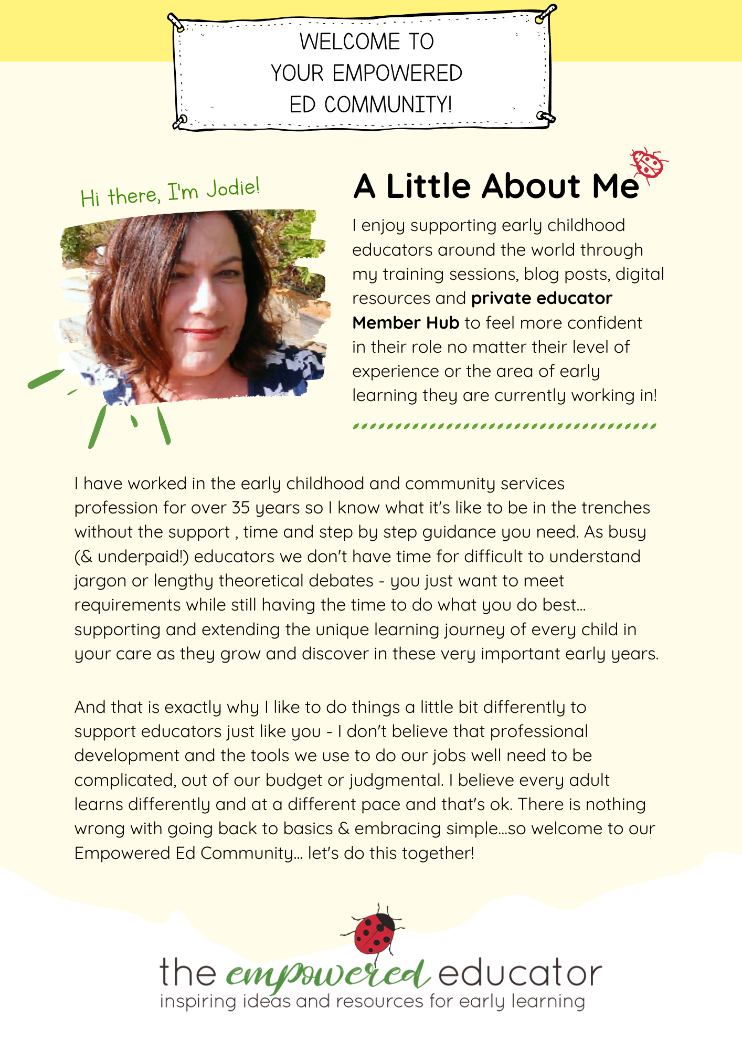
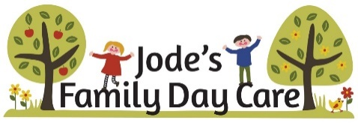

(Replace logo with your own)
Family Feedback Survey – Centre Version
At (insert your centre name here), we value your suggestions and ideas because we know that working in partnership with families will help me to create the best possible program for your children. I’d so appreciate it if you could take 5 minutes to complete the following questions so that we can continue to offer a high-quality service that meets not only your needs as parents but also the needs of your children.
Parent/Carer Name: ………………………………………………………………………………………………………………
Child/Children’s Name/s: ……………………………………………………………………………………………………………….
Please feel comfortable to remain anonymous if you desire and not add your details above.
How long has your child/children been coming to …………………………………………………
_______________________________________
How did you first find out about our Early Learning Centre?

What did you find the most helpful when visiting our centre for the first time?

Do you feel that we know your child, their likes and dislikes and what makes them feel safe and happy?
Yes
No

Do you feel that the centre toys and equipment are safe and well maintained?
Yes
No

I feel that …………………………… encourages children to respect the environment and provides hands on opportunities for active learning through eco-friendly actions, projects, routines and play.
Yes
No

Do you know where to view your child’s weekly/monthly program?
Yes
No

Please choose your most likely answer using the rating scale below:
My initial visit and the enrolment process was welcoming and thorough.

My child seems to enjoy coming to …………………………..…………………………………………

As a parent or carer I have felt welcome here at ………………………………………………………

I feel confident that I would be immediately notified should there be an incident involving
the safety of my child.

I am satisfied with the way educators’ approach and manage daily routines such as
separation and goodbye transitions, nappy changes, toileting, rest time, meal and snack
times.

I feel confident that the educators focus on and extend my child’s abilities and what they
CAN do instead of what they CAN’T do.

The individual dietary needs of my child are discussed, documented and followed
consistently (i.e. cultural requirements, allergies, intolerances).

I am given the opportunity to share my ideas about improvements or concerns.

The family noticeboards and displays are accessible and easy to understand.

I feel like the educators treat all information about my family and child as confidential.

The educators seem happy and work well together as a team.

Please choose from the selections below – you can tick more than one if you choose to.
What would you like to see happen more often at …………………………………………?
- Outdoor play time
- Family events
- Events/activities embracing family Culture & Diversity
- Communication with parents
- Information Sessions
- Newsletters
- Sustainability Activities
- Behaviour Management
- Support for special needs children and inclusive practices

Overall, are you happy with ……………………………………. Early learning service/FDC?
Yes
No

What are 2 things you like MOST about ………………………………………………………………

What are 2 things you like LEAST about ………………………………………………………………

THANKS FOR TAKING TIME OUT OF YOUR BUSY DAY –
WE DO SO APPRECIATE YOUR FEEDBACK!

CHILDREN’S VIEWS & VOICES PICTURE SURVEY - 3 Years Up
Notes for Parents & Carers – Please Read First
Can you please take 5 minutes to read aloud the 3 questions below to your child then provide some drawing materials for them to answer through creativity? Encourage your child to draw what they want to as you talk together about the question – don’t be concerned if they go ‘off topic’ or the drawing doesn’t look like anything to you. If your child begins describing what they are drawing you might like to add that into the description box under the drawing box but please only write what they are saying ‘in their own words’.
There is no need to keep drawings within the box frames or ‘inside the lines’ – if they want to go big please attach any other sheets of paper they choose to draw on as well.
This section of the feedback survey is all about hearing and documenting the children’s voices and making sure they have an opportunity to contribute, feel heard and included in decisions being made about the care space they spend a lot of time during each week! Children 4 years and up may prefer to tell you a story and ask you to write it down for them – this is fine too, don’t pressure them to draw or take part if they don’t want to!
I recommend completing this section of the survey when your child is happy and talkative rather than hungry, tired or grumpy because we want it to be fun…not a chore or something to cause stress to you both!

Ready to Start? Let’s Do It!

Hi There!
We love making it fun for you at ……………………….. but I really want to know what YOU think about coming because YOU are a very important person to us here at …………………………………
So, let’s get the pencils or crayons out and do some drawing to answer 3 special questions (if you are a little bit older and don’t want to draw, you can just write some words down to describe your thoughts or ask for your adult’s help!) Ready? Go!

- What would you draw to tell me something you don’t like very much about coming to …………………………………………………………………………

If you want to, what would you say (in your own words) is something that would make coming to …………………………………….. better?
In My Own Words…

- Think about what you like the most when you come to …………………………………… then draw a picture of your favourite toys, activities or places to play!

What would you say is the best part of coming to ……………………………….?
In My Own Words…

- Where do you like to go first when you arrive at …………………………….. for the day? Who do you say hello to?

All Finished!

Thank-you for sharing your drawings and ideas with me!

